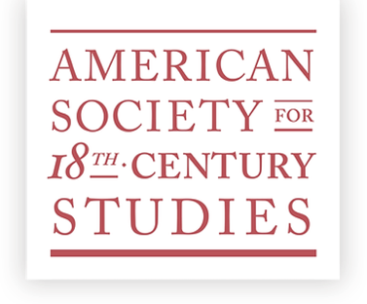

ASECS Policy on Ethics and Professional Conduct

The American Society for Eighteenth-Century Studies (ASECS) is committed to the free exchange of ideas in an environment of inclusion, safety, and mutual respect in all its activities. All members and participants involved in ASECS-sponsored activities, including employees, contractors, vendors, volunteers, and guests, are expected to engage in ethical and respectful behavior and to preserve the highest standards of scholarly and professional conduct, whether the activities occur in the context of the Annual Meeting or other ASECS-sponsored undertakings. The Society holds the right to redress all forms of discrimination, harassment, coercion, bullying, and abusive behavior against participants based on their perceived race, class, ethnicity, national origin, citizenship, religion, age, ability, sex, gender, sexual orientation, rank, or status.

ASECS uses the definition of the US Equal Employment Opportunity Commission guidelines that anyone witnessing or affected by the offensive conduct, and not only the person at whom the conduct is directed, may be considered a victim of harassment or bullying.

Approved by the Executive Committee February 2025

